
EMPLOYEE PERFORMANCE DECISION SUPPORT SYSTEM
GROUP MEMBERS :
SYLVIA MULLA- 668830
IMMACULATE MWENDWA-669802

Problem Definition & System Design

Employee Performance Decision Support System
The Decision Problem
There are several limitations when assessing the performance of employees manually as follows:
- Subjectivity and Bias: Without a common process, the performance appraisal process is likely to be affected by personal opinion, recency, and leniency.
- Inconsistency: Each manager uses their own criteria. The rating of one supervisor might be 7, but another one will provide a 5 rating for the same job.
- Laborious: The manual evaluation of numerous employees, score calculation, and recommendation preparation may take days or even weeks, time that can be used by human resources managers for other tasks.
- Non-transparency: Employees are unaware of the decision-making process, leading to dissatisfaction and detachment.
The introduction of our Decision Support System (DSS) addresses the above issues and provides a standardized and objective performance evaluation process and relevant recommendations.
Decision Makers
The system is made up of three important decision makers:
- Human Resource Managers: They monitor the performance trends of the company, identify departments requiring assistance, and provide an unbiased and uniform evaluation process for promotions and training.
- Supervisors: They assess their employees objectively, justify their training or promotion proposals by providing statistical information, and recognize employees with poor performances or having great potential.
- Executives: They monitor the performance trends of the company and evaluate the effectiveness of training programs using objective performance information.
Inputs & Outputs
Inputs
- Attendance Rate: Ratio of attended days to total scheduled days. Indicators of loyalty and reliability. Employees’ lack of attendance negatively affects overall team performance.
- Completed Tasks: Number of assignments completed by the employee within the timeframe specified for the evaluation. Indicates productivity level.
- Productivity Score (0-100): A numerical rating based on productivity and work done. It considers the volume of work and its quality.
- Supervisor Evaluation (1-10): Qualitative assessment of employee made by a supervisor. Assesses intangible aspects like cooperation, motivation and others.

Outputs
- Performance Score (0-100): Numeric indicator which is a result of processing all inputs.
- Performance Category according to the score achieved:
- High Performing Employee
- Average Employee
- Employee Who Needs Improvement
- Action Required (recommendation):
- Promotion
- Maintenance
- Training Required

Decision Logic
The decision model incorporates a score-based approach where various components have their assigned weight to determine the performance score.
Formula
Performance Score = (Attendance x 0.2) + (Task Completion x 0.3) + (Productivity x 0.3) + (Adjusted Supervisor Rating x 0.2)
Supervisor rating (1-10) is adjusted to 0-100, as with other measurements.
Decision Criteria
- Above 80: High Performer – Promote. Acknowledging the top talent and ensuring their retention.
- 60 to 80 (inclusive): Average Performer – Maintain. Employee meets the requirements; nothing more is required.
- Below 60: Needs Improvement – Requires Training. Demonstrates that the employee lacks certain skills.
All the above constitutes decision making and the transformation of unstructured data into structured information used for decision making, the primary objective of a Decision Support System.
System Architecture
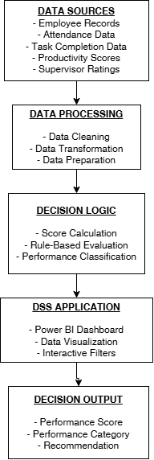
Overview of System
Employee information (inputs) is fed into the system. Then, based on weights and rules, the Decision Engine calculates the Performance Score, determines the Category, and gives the Recommendation. The output is displayed using the Power BI interface.

Data Description and Documentation
Source of Data
This dataset was sourced from Kaggle, which is a popular database website. It is a synthetic dataset that contains information regarding the performance of employees from various departments such as sales, research and development, and human resources.

Structure of Dataset
The cleaned dataset has 6 columns and 1,000 employee records. Description Column:
- EmployeeID-Text: Unique ID assigned to each employee (RM297, etc.)
- Department-Text: Department where the employee works (sales, R&D, or HR)
- Attendance-Integer: Percentage attendance record (0-100%)
- Tasks Completed-Integer: Number of tasks completed by the employee
- Productivity-Integer: Productivity rating out of 100
- Supervisor Rating-Integer: Supervisor’s rating out of 10
Steps Involved in Data Cleansing
This helps ensure that data remains suitable for analysis:
- Removing Duplicates: Search and deleting duplicate EmployeeIDs from the dataset.
- Missing Data Treatment: Check for any missing values on key columns; there were none.
- Format Standardization: Ensure that numbers remain integer while texts are in proper format.
- Validation: Confirm numbers fall within their appropriate ranges (for example Attendance 0-100, Rating 1-10).
The selection of these factors ensures a complete assessment of the employees:
- Attendance indicates dependability.
- Completed Tasks indicate productivity quantity.
- Productivity indicates productivity, quality and efficiency.
- Supervisor Rating incorporates soft aspects such as cooperation.
These indicators provide for both objective and subjective assessments of employees.

Cleaned Dataset
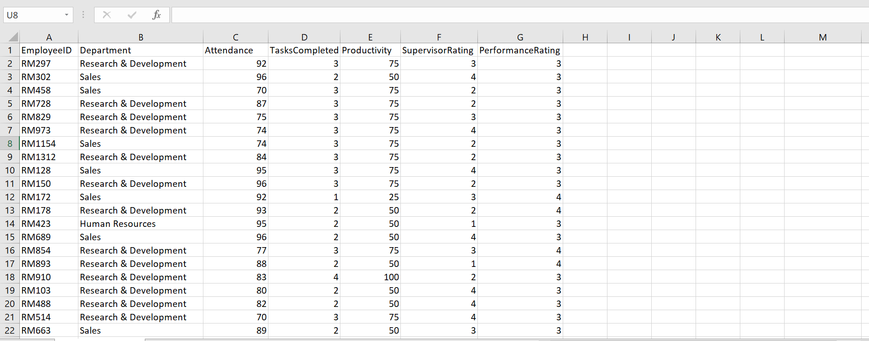
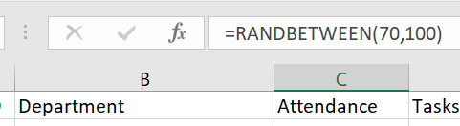

Decision Model Explanation

How Performance Scoring Is Done
Performance Score is determined by the method of calculating a weighted average with different weights, depending on importance:
- Completed tasks (30%)
- Biggest weight, since completed tasks are the indicator of performance itself.
- Productivity (30%)
- Same weight as tasks, thus the quality of work counts the same.
- Attendance (20%)
- Important, yet not crucial in terms of output.
- Supervisor Rating (20%)
- Least weight because of possible bias of any individual manager.
Thresholds For Decision-Making Criteria
- 80 and above – high performer, consistent outperformance of expectations.
- 60 to 80 – average performer, consistently meets expectations.
- Below 60 – needs improvement, underperforming expectations.
Action Plan on Recommendations by Category
- High Performer – promote to a higher-level position with higher pay rate and responsibilities.
- Average Performer – maintain existing role and monitor for performance improvements.
- Needs Improvement – require training courses participation and determine the way forward with performance management plans.
The Benefits of Such an Approach
- Fair And Objective
- Equal treatment for all employees according to the same formula and the same criteria.
- Data Driven
- The decision made using actual data points.
- Transparent
- Employees know what and how contributed to the score.
- Actionable
- The score results in a concrete business action step.

Dashboard Design

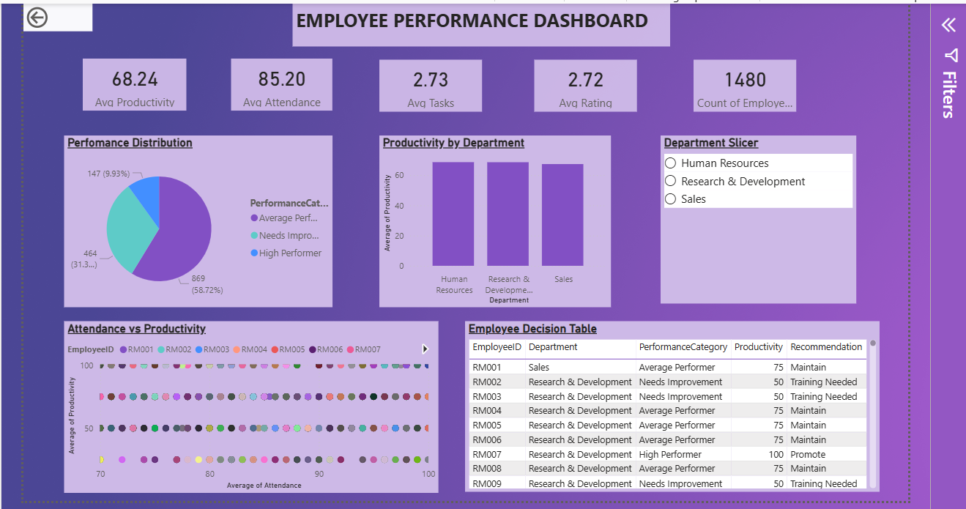

Dashboard Explanation
This dashboard displays employee productivity in various departments within an organization. This tool can be used to analyze outstanding employees, employees that require further training, and general trends within the departments.

2. KPIs (Upper Section)
KPI Value Meaning
Total Employees → EmployeeID (Count)
Avg Productivity → Productivity (Average)
Avg Attendance → Attendance (Average)
Avg Tasks → TasksCompleted (Average)
Avg Rating → SupervisorRating (Average)
Average Productivity= 71.75- Average productivity score of all employees is 71.75 out of 100
Departmental Average Productivity (Upper Left - Bar Graph)
- Shows the average productivity of the respective departments.
- Displays the highest bar in case of the Sales department.
- Helps to distinguish the better-performing departments.
Attendance & Productivity (Upper Middle - Scatter Plot)
- Every data point indicates the individual performance of an employee.
- X-axis refers to attendance.
- Y-axis shows productivity.
- Shows the attendance and productivity of employees.
- Usually, higher attendance translates to better productivity.
Employee Performance Distribution (Upper Right - Pie Chart)
- Splits the total employee strength into three segments:
High Performance (Blue)
Average Performance (Purple)
Improvement Needed (Teal)
Department Slicer
This helps us navigate through the employee departments to make it eaier for visualization of the dashboard.

Challenges experienced throughout the project
- Data Preparation
The dataset obtained did not fully match the required system inputs, particularly the absence of an attendance variable. This required the generation of synthetic attendance data, which, although necessary, may not perfectly reflect real-world conditions.

- Data Transformation
Certain variables, such as performance ratings, existed as restricted measurements which needed conversion into standardized measurements that would enable proper analysis. The transformation process required validation procedures to ensure its accuracy.

- Power BI software development faced technical difficulties because its visual display configurations proved complicated to implement. The team needed to resolve two problems which included incorrect data aggregation through sum calculation instead of average calculation and scatter plot field setup difficulties.

- The team members faced compatibility problems when they attempted to share the Power BI (.pbix) file with each other. The team encountered problems to access and connect to the dataset because of their different software environments and file handling methods which required them to find new methods to share data and establish data connections.

Conclusion
The Employee Performance Decision Support System transforms HR data into meaningful business information by using the standardized and weighted scores for performance assessment.
HR personnel will be able to identify employees who require promotions and further training within a short time using a Power BI dashboard.
Future upgrades to the system could include the addition of real-time data feed, attrition prediction, and peer review scorecard.

